MEDIA RELEASE

Twenty-one Australia Awards scholars from Nepal to depart for Australia

On 1 December, Australia’s Ambassador to Nepal, HE Felicity Volk and Chief Secretary of Government of Nepal, Dr Baikuntha Aryal handed over Australia Awards scholarships to 21 Nepali recipients.

The recipients of the Australian Government’s prestigious Australia Awards scholarships include 15 from the public sector. Of the total, 14 are women and one is a person with disability.

Sixteen of the Australia Awards scholars will start their master’s degree programs at world class universities in Australia in early 2024, and the remaining five will commence later in the year.

Addressing the handover ceremony, Chief Secretary Dr Aryal congratulated the Australia Awards recipients and thanked the Australian Government for providing opportunities for Nepali students to pursue higher studies in Australia.
“I am confident that these world class educational opportunities for the scholars, the majority of whom are government officials, will be an instrumental contribution to the formulation and implementation of government policies in Nepal,” Chief Secretary Dr Aryal said.
Ambassador Volk encouraged the Australia Awards scholars to experience the diversity and richness of multicultural Australia and build strong linkages with Australian people and institutions during their time in Australia.
“The friendship that exists between our countries is vibrant, flourishing, multi-dimensional and characterised by great respect and partnership. I encourage the scholars to connect with the network of Australian alumni in Nepal when they return. And I look forward to seeing their vital contributions to Nepal, drawing on their new knowledge and skills in public policy development, health, infrastructure development, policy for people living with disability, the empowerment of women and girls, education, sustainable energy production and transmission, and more.”

Australia Awards Scholarships are long-term development awards funded by the Australian Government’s Department of Foreign Affairs and Trade. The scholarships provide emerging leaders with study and research opportunities to develop skills, knowledge and networks, to drive change and contribute to development in their home countries. Many Australia Awards alumni go on to hold senior positions in government, civil society and business on their return home.

Scholarships have been a key feature of Australia’s foreign policy since the Colombo Plan in the 1950s. Since then, more than 100,000 individuals from around the world have received an Australian Government scholarship to study in Australia. More than 1,100 Nepalis have pursued study and research in Australia with the support of Australia Awards.

Australia Awards scholars are supported throughout the period of their studies in Australia. Benefits include full tuition fees, return airfares, contribution to living expenses and medical insurance.

Applications for the next cycle of Australia Awards Scholarships will open in February 2024.

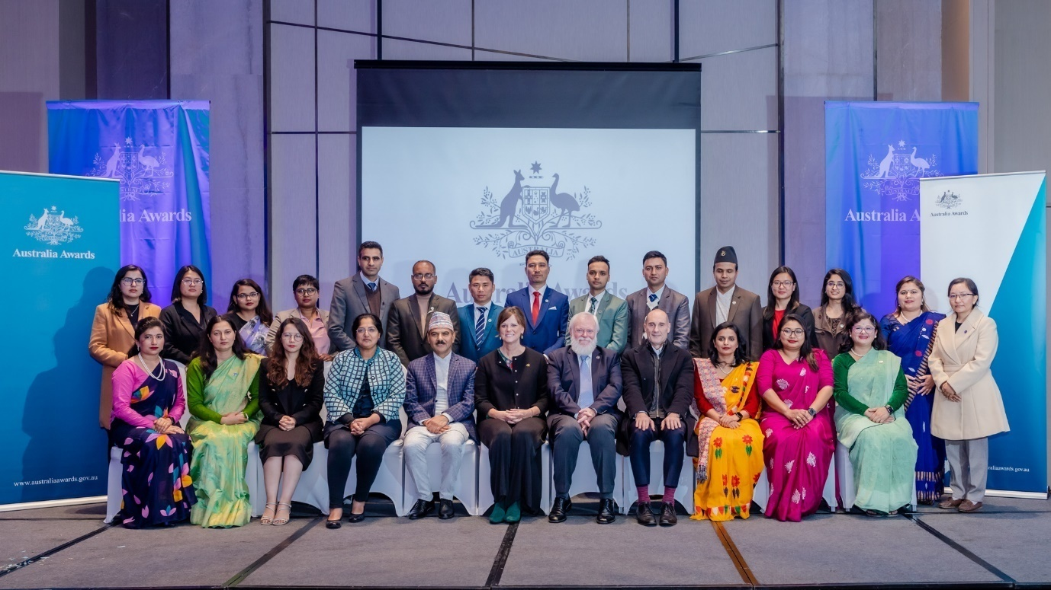
Recipients of the Australia Awards 2024 with Chief Secretary Dr Baikuntha Aryal, Australia’s Ambassador to Nepal and Australian Embassy officials during the Australia Awards Ceremony in Kathmandu on Friday, 1 December 2023. Photo: Australian Embassy

